**Question 1:User Input 2 values, when provide 2nd value as 0, Divide by Zero exception should throw**

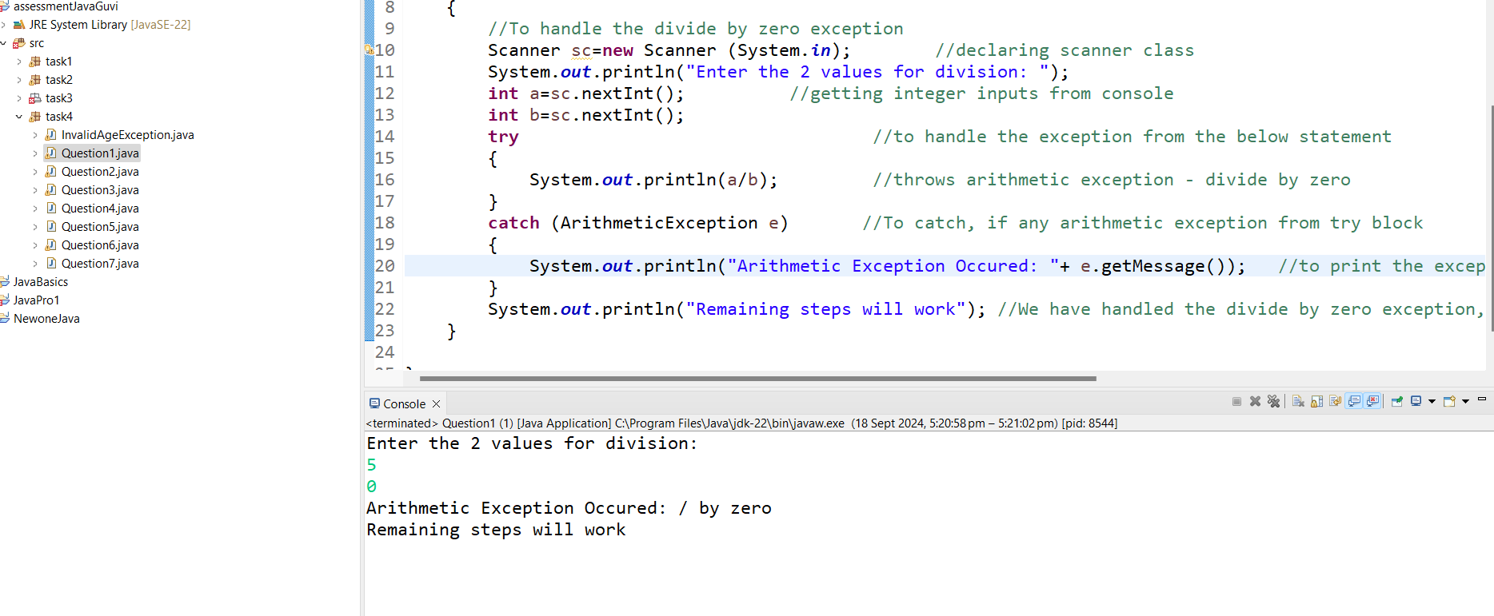

**Question 2: Array Index Out Of Bound Exception and String Index Out of Bound Exception**

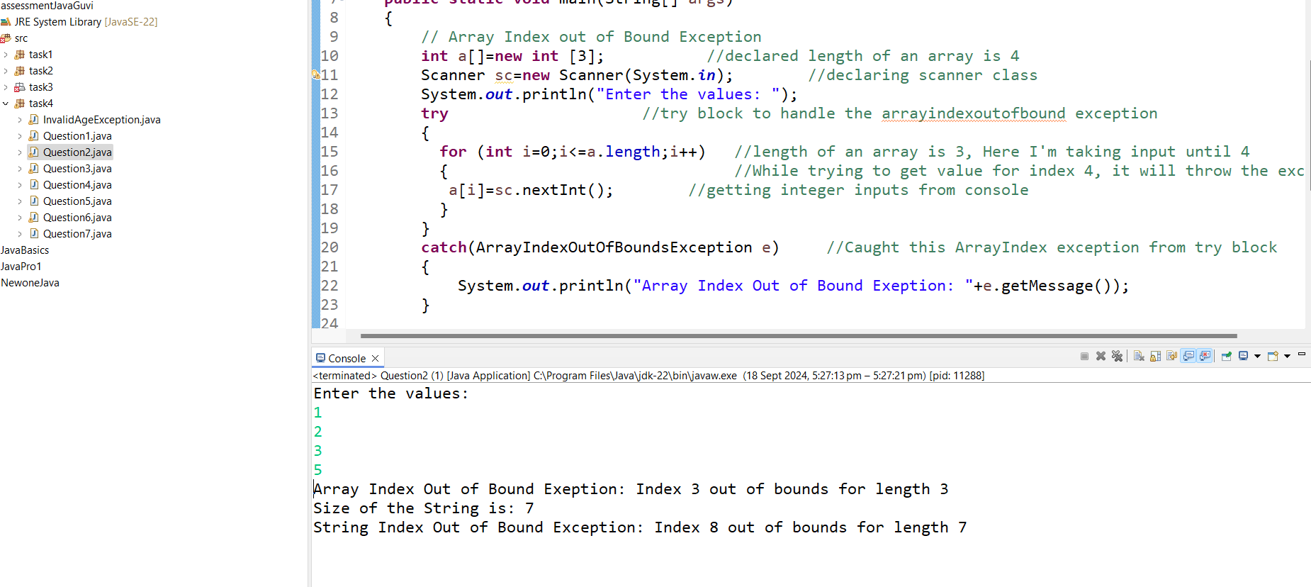

**Question 3: Custom Exception created as “Invalid Age Exception”, will occur when age less than 18**

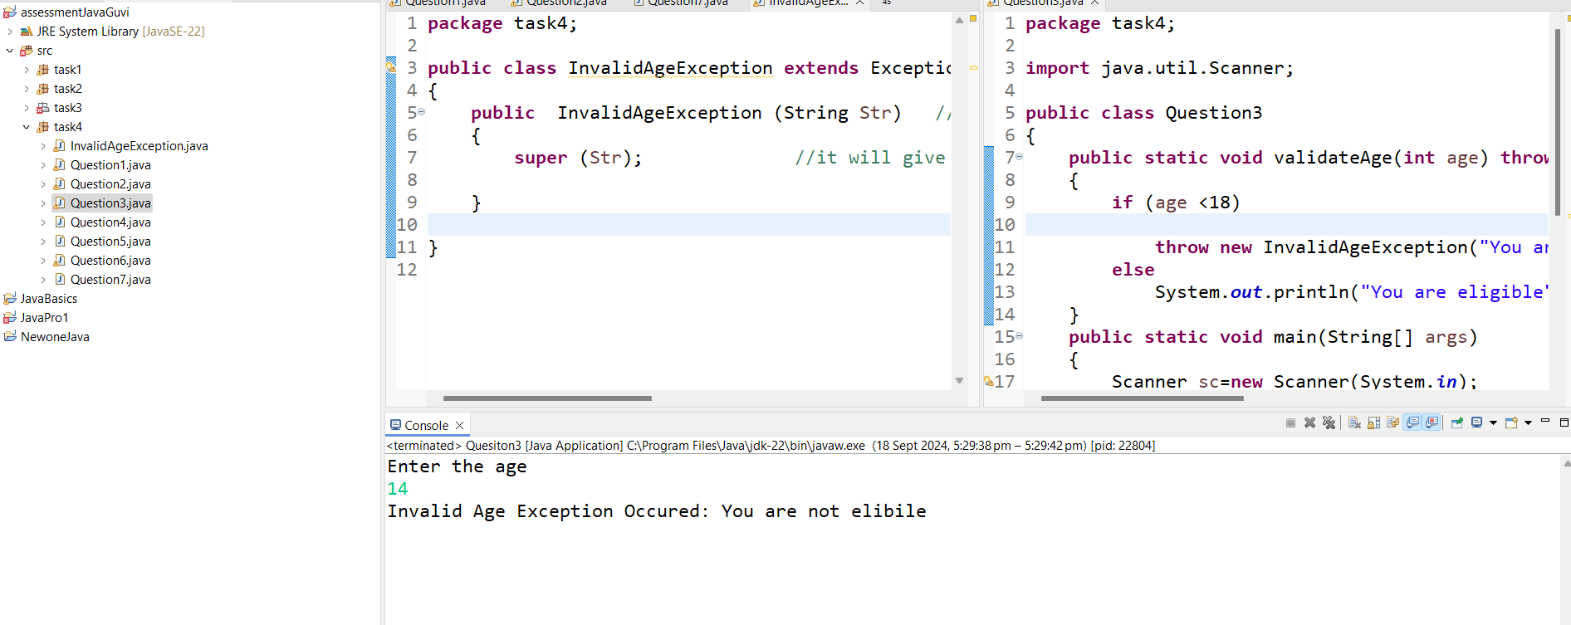

**Question 4: File not Found Exception will occur, while provide incorrect file path**

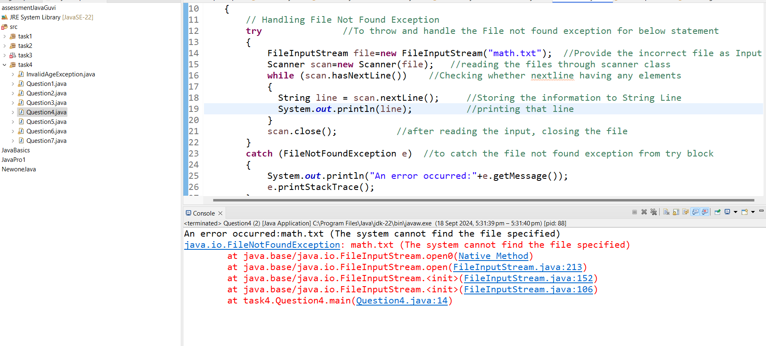

**Question 5: Create and remove the elements from Array list. Used Remove all and clear method**

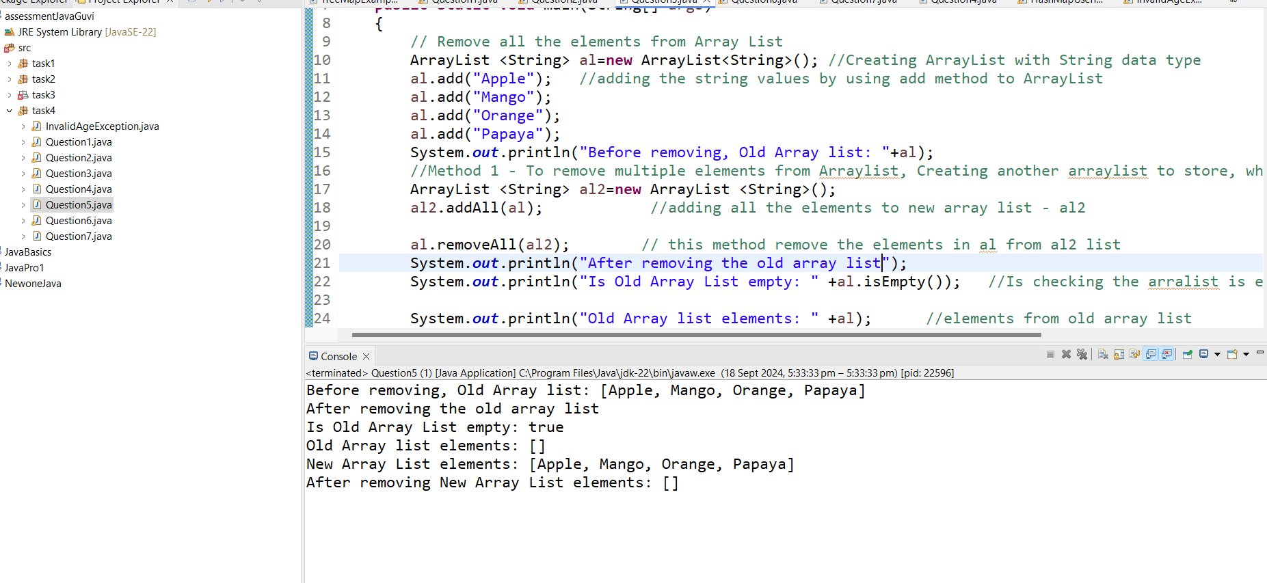

**Question 6: Tree map created with Id and Employee name to print the names in alphabetical order**

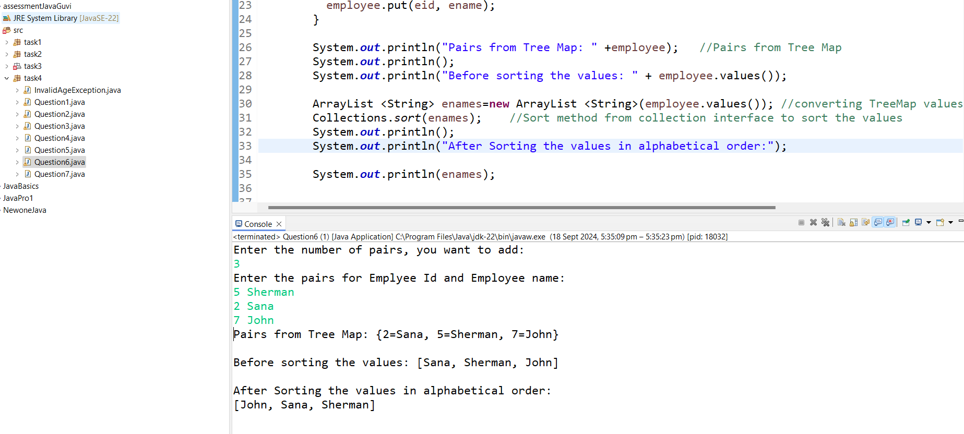

**Question 7: Convert List to Array**

